Customer Diversification and Revenue Optimization of a Medical Equipment Supplier

**A Proposal Report for the BDM Capstone Project**

Submitted by

Name: Haifa Abdul Sathar

Roll number: 23f1002330



IITM Online BS Degree Program,

Indian Institute of Technology, Madras, Chennai Tamil Nadu, India, 600036

**Contents**

1. Executive Summary 3
2. Organization Background 3
3. Problem Statement 4
   1. Problem statement 1 4
   2. Problem statement 2 4
4. Background of the Problem 4
5. Problem Solving Approach 4
6. Expected Timeline 5
7. Expected Outcome 6

**Declaration Statement**

I am working on a Project Title “Customer Diversification and Revenue Optimization of a Medical Equipment Supplier”. I extend my appreciation to **Al Wafer Medical Equipments and General Trading LLC**, for providing the necessary resources that enabled me to conduct my project.

I hereby assert that the data presented and assessed in this project report is genuine and precise to the utmost extent of my knowledge and capabilities. The data has been gathered through primary sources and carefully analyzed to assure its reliability.

Additionally, I affirm that all procedures employed for the purpose of data collection and analysis have been duly explained in this report. The outcomes and inferences derived from the data are an accurate depiction of the findings acquired through thorough analytical procedures.

I am dedicated to adhering to the information of academic honesty and integrity, and I am receptive to any additional examination or validation of the data contained in this project report.

I understand that the execution of this project is intended for individual completion and is not to be undertaken collectively. I thus affirm that I am not engaged in any form of collaboration with other individuals, and that all the work undertaken has been solely conducted by me. In the event that plagiarism is detected in the report at any stage of the project's completion, I am fully aware and prepared to accept disciplinary measures imposed by the relevant authority.

I agree that all the recommendations are business-specific and limited to this project exclusively, and cannot be utilized for any other purpose with an IIT Madras tag. I understand that IIT Madras does not endorse this.

Signature of Candidate: 

Name: Haifa Abdul Sathar

Date: 25/10/2024

# **Executive Summary**

1.1 **Al Wafer Medical Equipments and General Trading LLC**, a leading B2B and B2C medical equipment supplier based in Dubai, UAE, is currently facing challenges related to customer concentration and fluctuating sales. A significant portion of its revenue comes from a small group of customers, making the business vulnerable to the risk of financial instability or revenue loss. If one or more key customers reduce or cease their purchases, it could significantly impact the company’s financial health. Additionally, the fluctuation in sales has led to revenue volatility, making it difficult to forecast and optimize operational decisions.

1.2 This Project titled “**Customer Diversification and Revenue Optimization of a Medical Equipment Supplier”** aims to address these issues by implementing data-driven strategies to reduce dependence on a few major clients and to stabilize and grow sales. Through a thorough analysis of existing data provided in excel sheets by the owner, the project will identify new market opportunities, enhance customer retention strategies, and implement pricing and product optimization models. By diversifying its client portfolio and introducing more efficient sales strategies, Al Wafer can not only mitigate the risk of revenue loss but also drive sustainable growth in an increasingly competitive market. This initiative will ensure long-term financial resilience and establish a more balanced revenue stream for the business.

1. Organization Background
   1. **AL WAFER MEDICAL EQUIPMENTS AND GENERAL TRADING LLC ,** established in 2013, is a premier medical and dental equipment supplier that provides a combination of new and durable professional refurbished equipment, disposable and material to medical professionals around the globe. The business operates in both B2B and B2C capacities with more than 10 years of experience. The business is owned by a medical graduate with years of experience in the medical field and run along with 3 staffs. Their warehouse is situated in Qusais which is around 10 km distant from their office. The business is operating in a highly competitive market with the presence of many similar traders around the region.

2.2 The business provides certified and proven premium Surgical, Medical and Dental equipment. Some of the product varieties offered are ECG Machines, Disposable Diagnostic Set, Wheelchair, Big Chemistry Analyser, Surgical Gloves, Portable X-ray, Microscope etc.

# **Problem Statement**

# Reducing the risk to the financial stability of the business due to concentration of business among a few customers, which can lead to dependency and vulnerability in a fluctuating market.

# Stabilizing sales across months, optimizing purchasing decisions, and expanding market reach.

# **Background of the Problem**

4.1 The issues faced by Al Wafer Medical Equipments and General Trading LLC could be due to poor marketing strategies for customer acquisition, customer retention and demand forecasting. Constant revenue from specific customers has led to neglect of diversifying the customer base. A lack of focus on broadening market outreach or exploring new customer segments may have led to an over-reliance on existing customers.

4.2 The concentration of business with a small number of clients can result in significant risks, as losing even one major customer could negatively impact financial performance. A lack of diversification in customers increases financial instability, especially during economic downturns or when market preferences shift. Low engagement customers are possible upcoming threats by posing a risk of churn.

4.3 Irregular sales cycles make it difficult to forecast demand accurately, leading to overstocking or stock outs. Externally, market competition, economic fluctuations, and changing consumer preferences are key factors contributing to sales volatility.

4.4 The major causes of these problems stem from insufficient diversification of the customer base, poor demand forecasting, and limited market reach. Addressing both internal and external factors is the key to stabilizing the business and driving sustainable growth.

# **Problem Solving Approach**

5.1 **Data Collection**. Data recorded in Excel sheets across a year was collected from the owner to provide a basis for analysis. The data includes Purchase details, Sales details (on a monthly basis) and Annual expenses. The Purchase and Sales datasheets contain Dates of Transaction, Supplier/Customer names and Bill Amounts.

5.2 **Exploratory Data Analysis** Exploratory Data Analysis provided insights into possible problems or threats to the business and basic statistical description of the business. Some of the methods to be used to analyze these problems thoroughly, understand root causes and devise strategies to mitigate them are

|  |
| --- |
|  |

### Data Analytics. Using sales data, customer data, and market trends to identify patterns and make data-driven decisions to Enhance accuracy in forecasting demand and marketing strategies.

5.2.2 **Customer Segmentation** Dividing customers into segments based on behavior, demographics, and purchase patterns helps tailor marketing strategies to different customer groups, reducing reliance on a few key customers.

5.2.3 **Churn Analysis** Using data analytics to predict customer churn based on past behavior and trends to identify high-risk customers and increase retention efforts to reduce churn.

5.2.4 **Predictive Sales Forecasting** Using historical sales data and trends to predict future sales and customer behaviors which will help in planning inventory and marketing, which in turn will reduce sales fluctuations by aligning supply with demand.

5.3 **Analysis Tools**. Analytical tools of Microsoft Excel and Python Libraries like Numpy and Pandas can provide in-depth analyses and data-driven techniques, allowing for a comprehensive approach to solving the business issues identified and improve business performance. Following tools would be used to analyse the collected data to derive valuable insights:-

* + 1. **Microsoft Excel.** It is used for preliminary data processing, data cleaning and analysis with the help of excel tools to uncover meaningful insights. It is a popular tool for fundamental computations and chart creation.

5.3.2 **Python libraries.** Python libraries such as Pandas for data analysis, Openpyxl for data manipulation using python in Excel Sheets and Matplotlib for visualization. Visualization using different charts provides a powerful mean to understand and compare data points.

# **Expected Timeline**

6.1 **Work Breakdown Structure** . The Project is expected to stretch across 3 months from September to November 2024 where Data Collection process had started on 10th September and the Project Final report with all the findings and inferences along with recommended solutions is expected to be submitted in the November cycle.

### 6.1.1 Data Collection Approaching the business owner and communicating about the project along with collection of existing data was carried out in this step.

### 6.1.2 Data Cleaning Data preprocessing steps such as applying a uniform format, removing missing values etc. were carried out.

### 6.1.3 Exploratory Data Analysis Initial analyses to gain insights about the business and formulating Problem Statement based on the available data were carried out.

### 6.1.4 Proposal Preparation and Submission Proposal Report has been prepared and is expected to be submitted on 1st November.

### 6.1.5 Extensive Data Analysis Building upon the exploratory data analysis, this phase involves more in-depth statistical or computational analyses. The objective is to draw more significant insights.

### 6.1.6 Mid Term Report Preparation and Submission The Mid Term Report will be prepared on the basis of further analyses and is expected to be submitted on 7th November.

### 6.1.7 Data Visualization and Interpretation Extensive analyses and drawing inferences from the data will be done to find possible solutions and recommendations to the problems.

### 6.1.8 End Term Report Preparation and Submission The Final Project Report including meaningful interpretations and recommendations to the problems will be documented and is expected to be submitted on 13th November.

## Gantt Chart

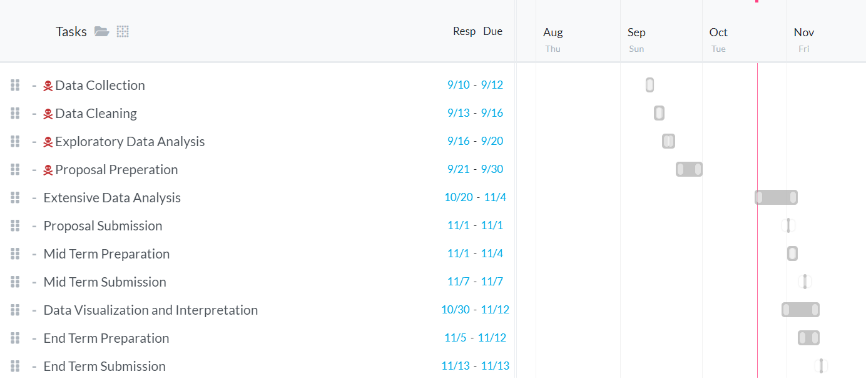

Fig 1. Gantt chart for the WBS

# **Expected Outcome**

7.1 The expected outcome of this project is a more diversified customer base and a stabilized revenue stream for Al Wafer. By analysing sales data, the company will identify key trends and patterns, allowing for improved demand forecasting and inventory management. This will reduce the risk of overstocking or stock outs, optimizing operational efficiency.

Through customer segmentation and churn prediction models, Al Wafer will be able to proactively address potential customer loss and target high-value clients more effectively. This will enhance customer retention and acquisition strategies, reducing dependence on a small group of customers and mitigating the risk of revenue concentration.

7.2 Furthermore, the implementation of tailored promotional strategies based on data insights will help smooth out sales fluctuations. This will lead to more consistent cash flow and profitability, enabling the business to plan more effectively for growth and investment. Overall, the project will enhance Al Wafer's financial stability by minimizing risks related to customer churn and sales volatility.